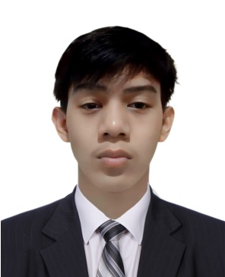 Honrad O. Gallardo

0262, Magtaking, Bugallon, Pangasinan

honradg71@gmail.com

+63 09994172888

**Career Objective:**

To leverage my technical expertise and passion for innovation as an IT specialist in a dynamic and forward-thinking organization. I aim to contribute my skills in system administration, network management, and cybersecurity to enhance the efficiency and security of IT infrastructure. With a commitment to continuous learning and a focus on problem-solving, I aspire to drive technological advancements, streamline operations, and ensure data integrity to support the organization's growth and success.

**JOB RELATED EXPERIENCES:**

Work: IT Specialist

Company: X Corp.

Address: San Francisco, USA

Date: 2021–2023

Work: Software Developer

Company: Google

Address: California, USA

Date: 2019-2021

Work: Cyber Security

Company: Gcash

Address: Manila, Philippines

Date: 2017-2019

**EDUCATIONAL ATTAINMENT:**

**College.**

(Academic Award) Magna Cum Laude

Bachelor’s Degree: Bachelor in Information Technology

School: University of Pangasinan

Date: 2013 – 2016

**Senior High School.**

(Academic Awards): Best in Computer, Best in Research, With Honors.

Strand: Information Communication Technology

School: Saint Columban’s College

Date: 2011-2013

**Junior High School**.

School: Saint Columban’s School Inc.

Date:: 2008-2011

**Elementary**

School: Magtaking Elementary School.

Date: 2002-2007

**HONORS AND AWARDS/ SEMINARS ATTENDED**

Award: Outstanding Project Developer.

Name of Event: Final Project

Place: University of Pangasinan

Date: June, 24, 2016

**SPECIAL SKILLS**

Programming Languages:

* Python
* Java
* JavaScript
* C++, C#, C
* Ruby
* Swift
* Android Studio
* Kotlin

Proficient in:

* Data Structures and Algorithms.
* Database Management.
* Web Development.
* Software Architecture.
* Debugging and Trouble Shooting.
* Cyber Security.
* Networking.
* Mobile Development.
* DevOps Practices.
* Ethical and Legal Hacking.

**REFERENCES (at least 3)**

Name: Elon Musk

Position: CEO

Company: X Corp

Contact Number: +415 703-2782

Name: Sundar Pichai

Position: CEO

Company: Google

Contact Number: +661 295-4949

Name: Martha Sazon

Position: CEO

Company Name: Gcash

Contact Number: +800 232-7634

Honrad Gallardo

0262, Magtaking

Bugallon, Pangasinan 2416

honradg71@gmail.com

+63 09994172888

27/08/2023

Jonathan Villareal

Human Resource Director

Panay Ventures International

936 Kiehn Route

West Ned, Tennessee, 11230

Dear Mr. Villareal:

I am writing in response to the part-time post at Panay Ventures International advertised on Facebook on April 29, 2023. With 19 years in the industry, I bring the mastery of python, java, kotlin, web development, c++, c#, swift, php and ruby that match the role's requirements.

At Tesla and SpaceX I gained expertise in Programming skills and team leadership to Panay Ventures' which a proud company as yours resonate with my career goals.

I'm eager to contribute to your team's success. My resume is enclosed for your review. I'm available for an interview at your convenience. Please reach me at 09994172888or honradg71@gmail.com. Thank you for considering my application.

Best regards,



Honrad Gallardo